EE 1004 Foundation of Information Systems and Data Analysis

Semester A 2023/24

Part II -- Exercise 01

**Question 1**

Consider the following figure, Write down:

(i) the set of nodes **V(G)** and edges **E(G)** (iv) the degree of each node

(ii) the order and size of graph (v) the total degree of graph

(iii) the neighborhood of each node

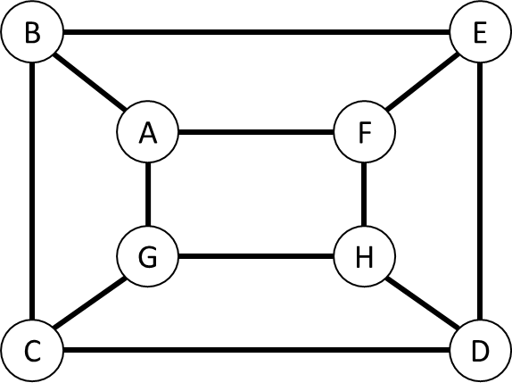

**Question 2**

Consider the following relationship:

(i) John likes Joan, Jean, and Jane;

(ii) Joe likes Jane and Joan;

(iii) Jean and Joan like each other.

Draw a digraph illustrating these relationships between John, Joan, Jean, Jane, and Joe, and Write down the number of vertices, edges, and the degree of each vertex

**Question 3**

Draw the following graphs:

(i) the complete graph K6;

(ii) the complete bipartite graph K2,4

And determine the number of edges on each graph.

**Question 4**

Identify which two of the following graphs are isomorphic, and give the justification(s)

|  |  |  |  |
| --- | --- | --- | --- |
|  |  |  |  |
| (a) | (b) | (c) | (d) |

**Question 5**

Show how the graph in the following figure can be drawn in the plane without crossings

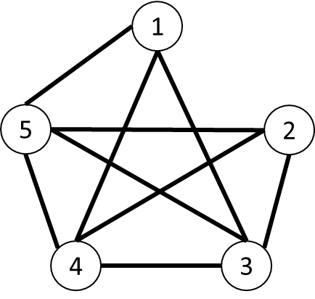

**Question 6**

Draw all the spanning trees in the following graph (hints: there are totally 8 spanning trees)

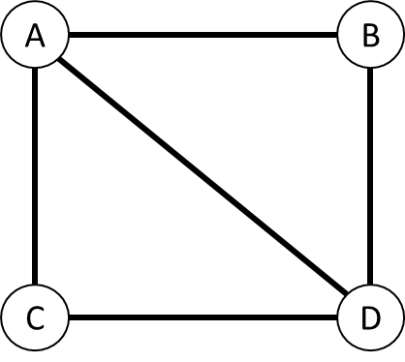

|  |  |
| --- | --- |
|  |  |
|  |  |

**Question 7**

With 5 vertices and 8 edges, draw:

(i) a simple graph;

(ii) a general graph with no loops;

(iii) a general graph with no multiple edges

**Question 8**

In the Petersen graph shown in follow, find:

(i) a trail of length 5;

(ii) a path of length 9;

(iii) cycles of lengths 5, 6, 8, and 9;

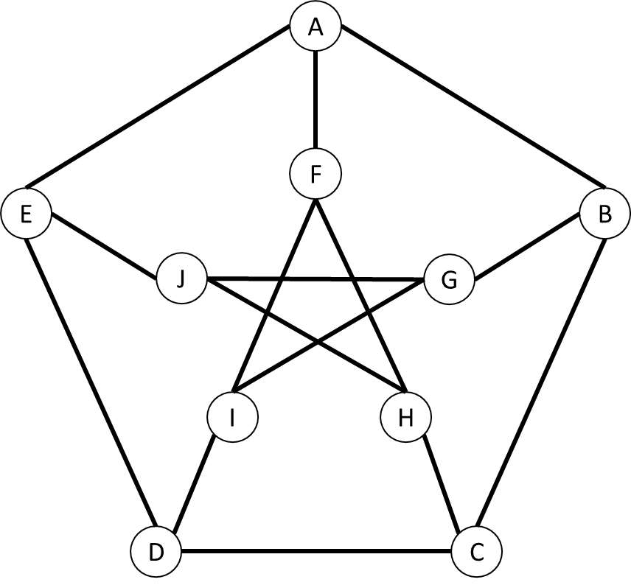

**Question 9**

Draw the adjacency matrices for the complete bipartite graph K3,4